CS-330 Final Project Reflection.

**Justify development choices for your 3D scene**.

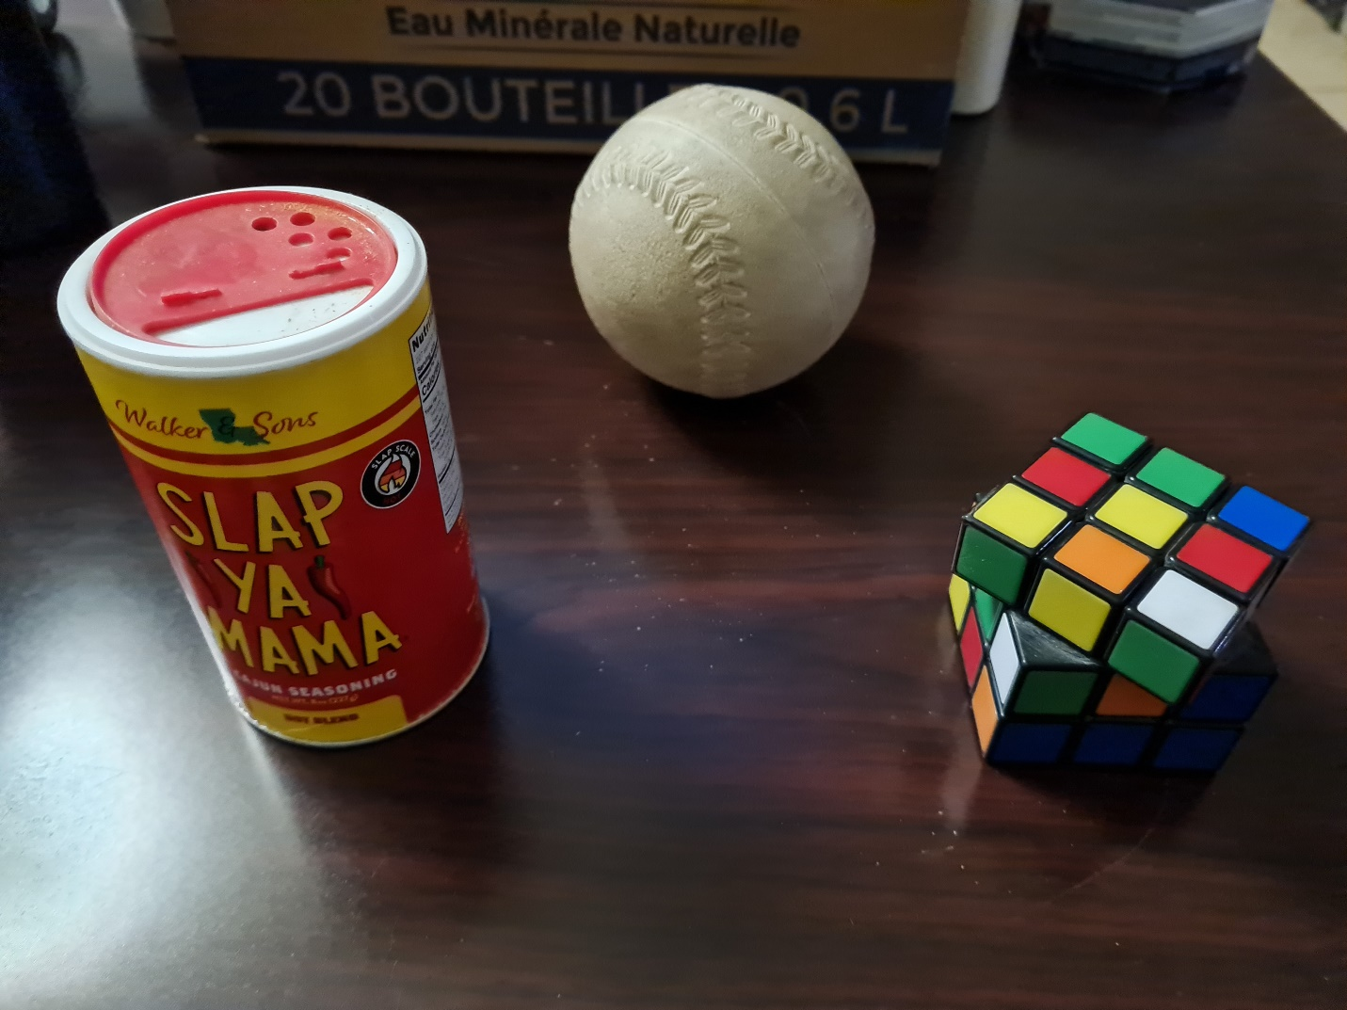

Originally, my scene consisted of three basic items based on the primitive shapes given for our assignments. However, I decided to change the sphere for a triangular shape to ease the construction of the shape. The decision also made sense to me because since the theme is sci-fi, and I thought sharp edges would look more mechanical. Additionally, the cylinder was also made only with 6 sides to make sure the textures would show all detail and be easier to construct. All objects are unique shapes and sizes which make a good demonstration of the transformations they underwent. Additionally, the Rubik’s cube base was also offset to show greater detail and

I added an additional piece to the it for the shape created out of multiple shapes requirement.

This is the cake toy I based the triangular shape that replaced the sphere.

**Explain how a user can navigate your 3D scene**.

The camera can move freely throughout the scene to allow the viewer to explore the objects in both perspective and orthographic view, changed with the P key. The keyboard AWSD keys are used to navigate forward, backward, left, and right. The Q and E keys move the camera up and down respectively. The mouse controls the view direction of the camera, and the mouse wheel controls the speed of the movement of the camera through the scene.

**Explain the custom functions in your program that you are using to make your code more modular and organized**. The shapesVertexShaderSource and shapesFragmentShaderSource shaders are used for all shapes, applying two textures to each shape. The lampVertexShaderSource and lampFragmentShaderSource shaders are also reused to create two lights in the scene. The flipImageVertically method flips texture images to prevent them from being incorrectly oriented every time they are loaded. UCreateShaderProgram, UDestroyShaderProgram, UCreateTexture, UDestroyTexture, UCreateMesh, UDestroyMesh, are all reusable and modular.